**// Subroutine : UpdateButtonClick_CONTRAST_BUTTON_THREAD()**

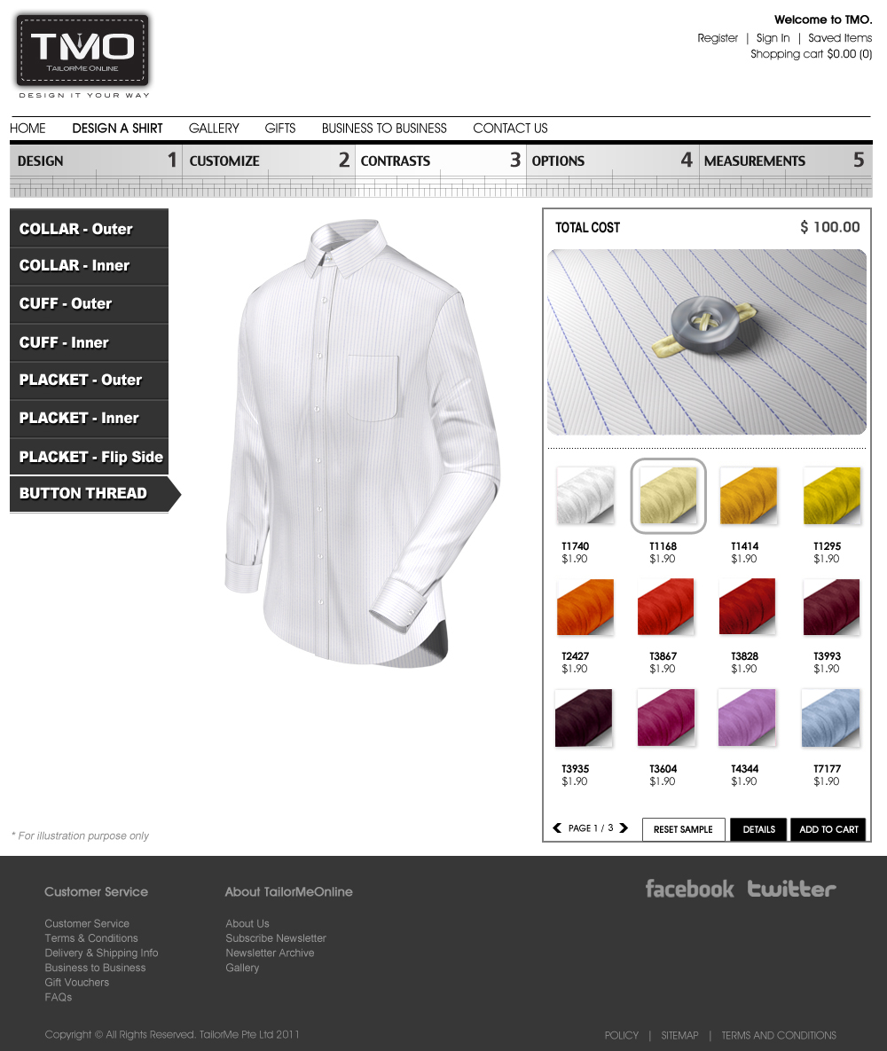

Upon clicking the any fabric button:

// Note : Number the thread icon in running number from 0001 onwards (ie. 0001, 0002, … , 0031)

ButtonLyr02[4] = ConvertToString(Icon Number);

PlacketLyr03[4] = ConvertToString(Icon Number);

PlacketContrastLyr05[4] = ConvertToString(Icon Number);

TieFixLyr04[4] = ConvertToString(Icon Number);

CollarLyr06[4] = ConvertToString(Icon Number);

CollarLyr08[4] = ConvertToString(Icon Number);

CuffLyr04[4] = ConvertToString(Icon Number);

ShirtLyr06[4] = ConvertToString(Icon Number);

ShirtLyr10 [4] = ConvertToString(Icon Number);

ShirtLyr14[4] = ConvertToString(Icon Number);

Call Subroutine : RefreshFilenames();

Call Subroutine : DisplayButton(); // This updates the thread window (same function to display button)

Call Subroutine : DisplayFullview(); // This updates the full shirt window

**// End of Subroutine : UpdateButtonClick_ CONTRAST_ BUTTON_THREAD()**